**SQL QUERIES**

**IBM HR Analytics Employee Attrition**

ALTER TABLE hr_employee

CHANGE COLUMN ï»¿Age Age INT;

**Class Balance & Summary**

**Attrition count & percentage**

SELECT

Attrition,

COUNT(*) AS count,

ROUND(100.0 * COUNT(*) / SUM(COUNT(*)) OVER (), 2) AS pct

FROM hr_employee

GROUP BY Attrition;

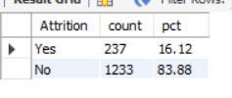

**-- Gender distribution**

SELECT Gender, COUNT(*) AS count

FROM hr_employee

GROUP BY Gender;

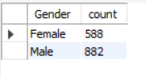

**Average age, tenure, income**

SELECT ROUND(AVG(Age),1) AS avg_age,

ROUND(AVG(YearsAtCompany),1) AS avg_tenure,

ROUND(AVG(MonthlyIncome),1) AS avg_income

FROM hr_employee;

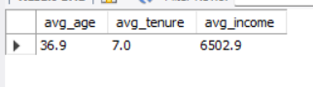

**Attrition Breakdown**

**Attrition Breakdown By Department**

SELECT Department,

COUNT(*) AS total,

SUM(CASE WHEN Attrition='Yes' THEN 1 ELSE 0 END) AS attrition_count,

ROUND(100.0*SUM(CASE WHEN Attrition='Yes' THEN 1 ELSE 0 END)/COUNT(*),2) AS attrition_pct

FROM hr_employee

GROUP BY Department

ORDER BY attrition_pct DESC;

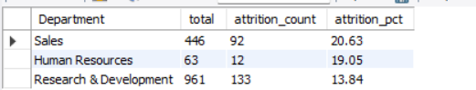

**Attrition Breakdown By JobRole**

SELECT JobRole,

COUNT(*) AS total,

SUM(CASE WHEN Attrition='Yes' THEN 1 ELSE 0 END) AS attrition_count,

ROUND(100.0*SUM(CASE WHEN Attrition='Yes' THEN 1 ELSE 0 END)/COUNT(*),2) AS attrition_pct

FROM hr_employee

GROUP BY JobRole

ORDER BY attrition_pct DESC;

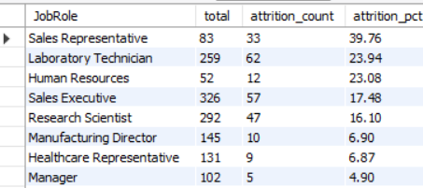

**Attrition Breakdown By OverTime**

SELECT OverTime,

COUNT(*) AS total,

SUM(CASE WHEN Attrition='Yes' THEN 1 ELSE 0 END) AS attrition_count,

ROUND(100.0*SUM(CASE WHEN Attrition='Yes' THEN 1 ELSE 0 END)/COUNT(*),2) AS attrition_pct

FROM hr_employee

GROUP BY OverTime;

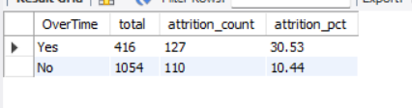

**Attrition Breakdown by By MaritalStatus**

SELECT MaritalStatus,

COUNT(*) AS total,

SUM(CASE WHEN Attrition='Yes' THEN 1 ELSE 0 END) AS attrition_count,

ROUND(100.0*SUM(CASE WHEN Attrition='Yes' THEN 1 ELSE 0 END)/COUNT(*),2) AS attrition_pct

FROM hr_employee

GROUP BY MaritalStatus;

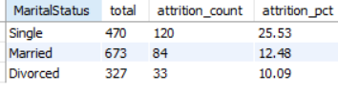

**Numeric Feature Analysis**

**Income vs Attrition**

SELECT Attrition,

ROUND(AVG(MonthlyIncome),0) AS avg_income,

ROUND(MIN(MonthlyIncome),0) AS min_income,

ROUND(MAX(MonthlyIncome),0) AS max_income

FROM hr_employee

GROUP BY Attrition;

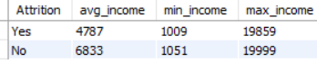

**Attrition by Age group**

SELECT CASE

WHEN Age < 25 THEN '<25'

WHEN Age BETWEEN 25 AND 34 THEN '25-34'

WHEN Age BETWEEN 35 AND 44 THEN '35-44'

ELSE '45+'

END AS age_group,

COUNT(*) AS total,

SUM(CASE WHEN Attrition='Yes' THEN 1 ELSE 0 END) AS attrition_count,

ROUND(100.0*SUM(CASE WHEN Attrition='Yes' THEN 1 ELSE 0 END)/COUNT(*),2) AS attrition_pct

FROM hr_employee

GROUP BY age_group

ORDER BY age_group;

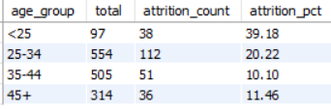

**Attrition by Tenure (YearsAtCompany)**

SELECT CASE

WHEN YearsAtCompany = 0 THEN '0'

WHEN YearsAtCompany BETWEEN 1 AND 3 THEN '1-3'

WHEN YearsAtCompany BETWEEN 4 AND 7 THEN '4-7'

ELSE '8+'

END AS tenure_group,

COUNT(*) AS total,

SUM(CASE WHEN Attrition='Yes' THEN 1 ELSE 0 END) AS attrition_count,

ROUND(100.0*SUM(CASE WHEN Attrition='Yes' THEN 1 ELSE 0 END)/COUNT(*),2) AS attrition_pct

FROM hr_employee

GROUP BY tenure_group

ORDER BY tenure_group;

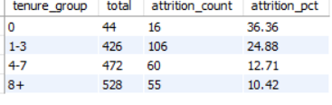

**Performance & Satisfaction**

**JobSatisfaction vs Attrition**

SELECT JobSatisfaction,

COUNT(*) AS total,

SUM(CASE WHEN Attrition='Yes' THEN 1 ELSE 0 END) AS attrition_count,

ROUND(100.0*SUM(CASE WHEN Attrition='Yes' THEN 1 ELSE 0 END)/COUNT(*),2) AS attrition_pct

FROM hr_employee

GROUP BY JobSatisfaction

ORDER BY JobSatisfaction;

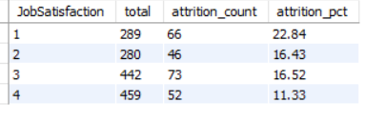

**WorkLifeBalance vs Attrition**

SELECT WorkLifeBalance,

COUNT(*) AS total,

SUM(CASE WHEN Attrition='Yes' THEN 1 ELSE 0 END) AS attrition_count,

ROUND(100.0*SUM(CASE WHEN Attrition='Yes' THEN 1 ELSE 0 END)/COUNT(*),2) AS attrition_pct

FROM hr_employee

GROUP BY WorkLifeBalance

ORDER BY WorkLifeBalance;

